Creating instance for windows:

22A81A05G0

K.PALLAVI

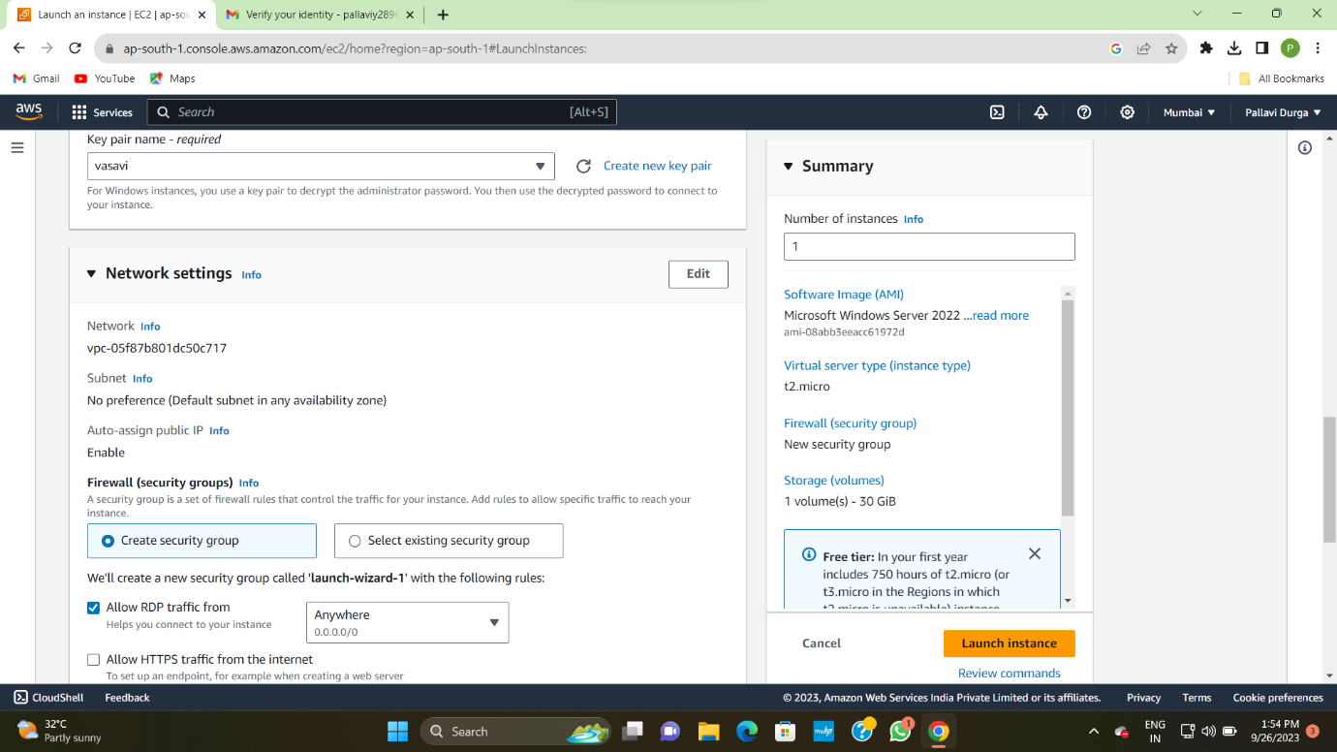

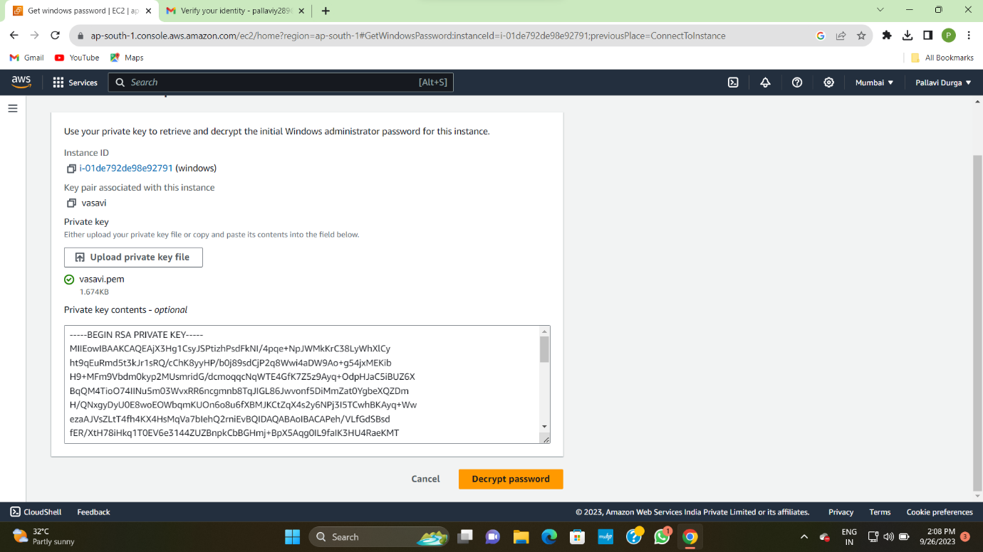

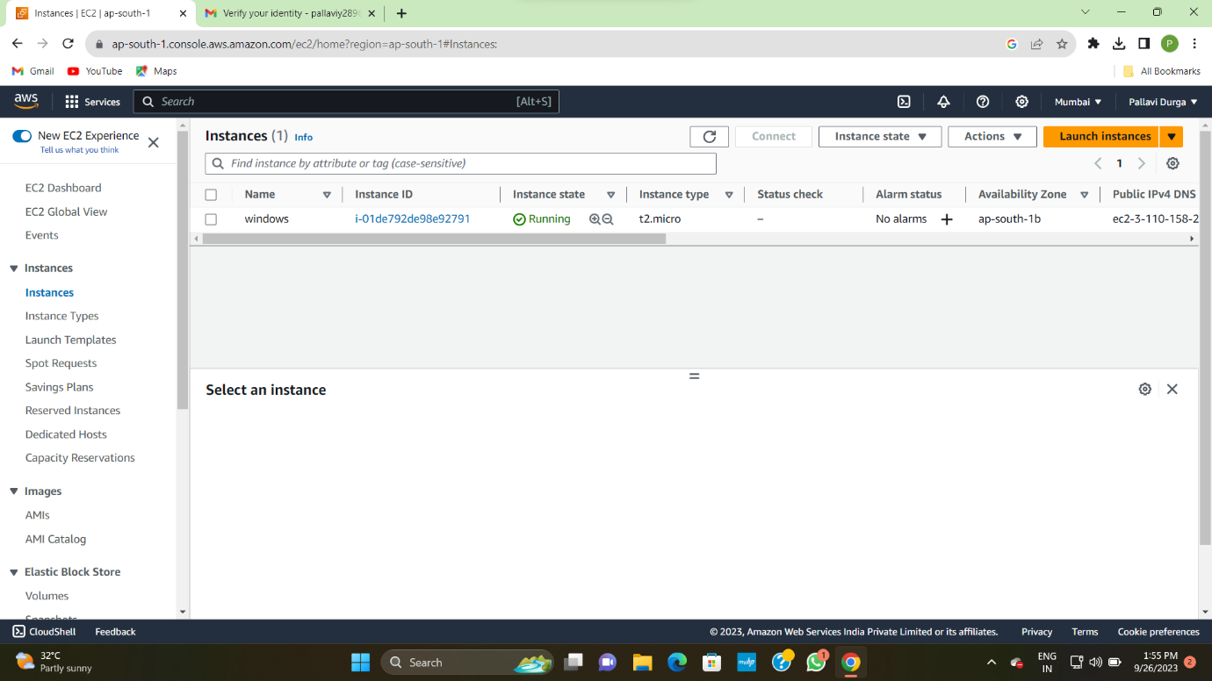

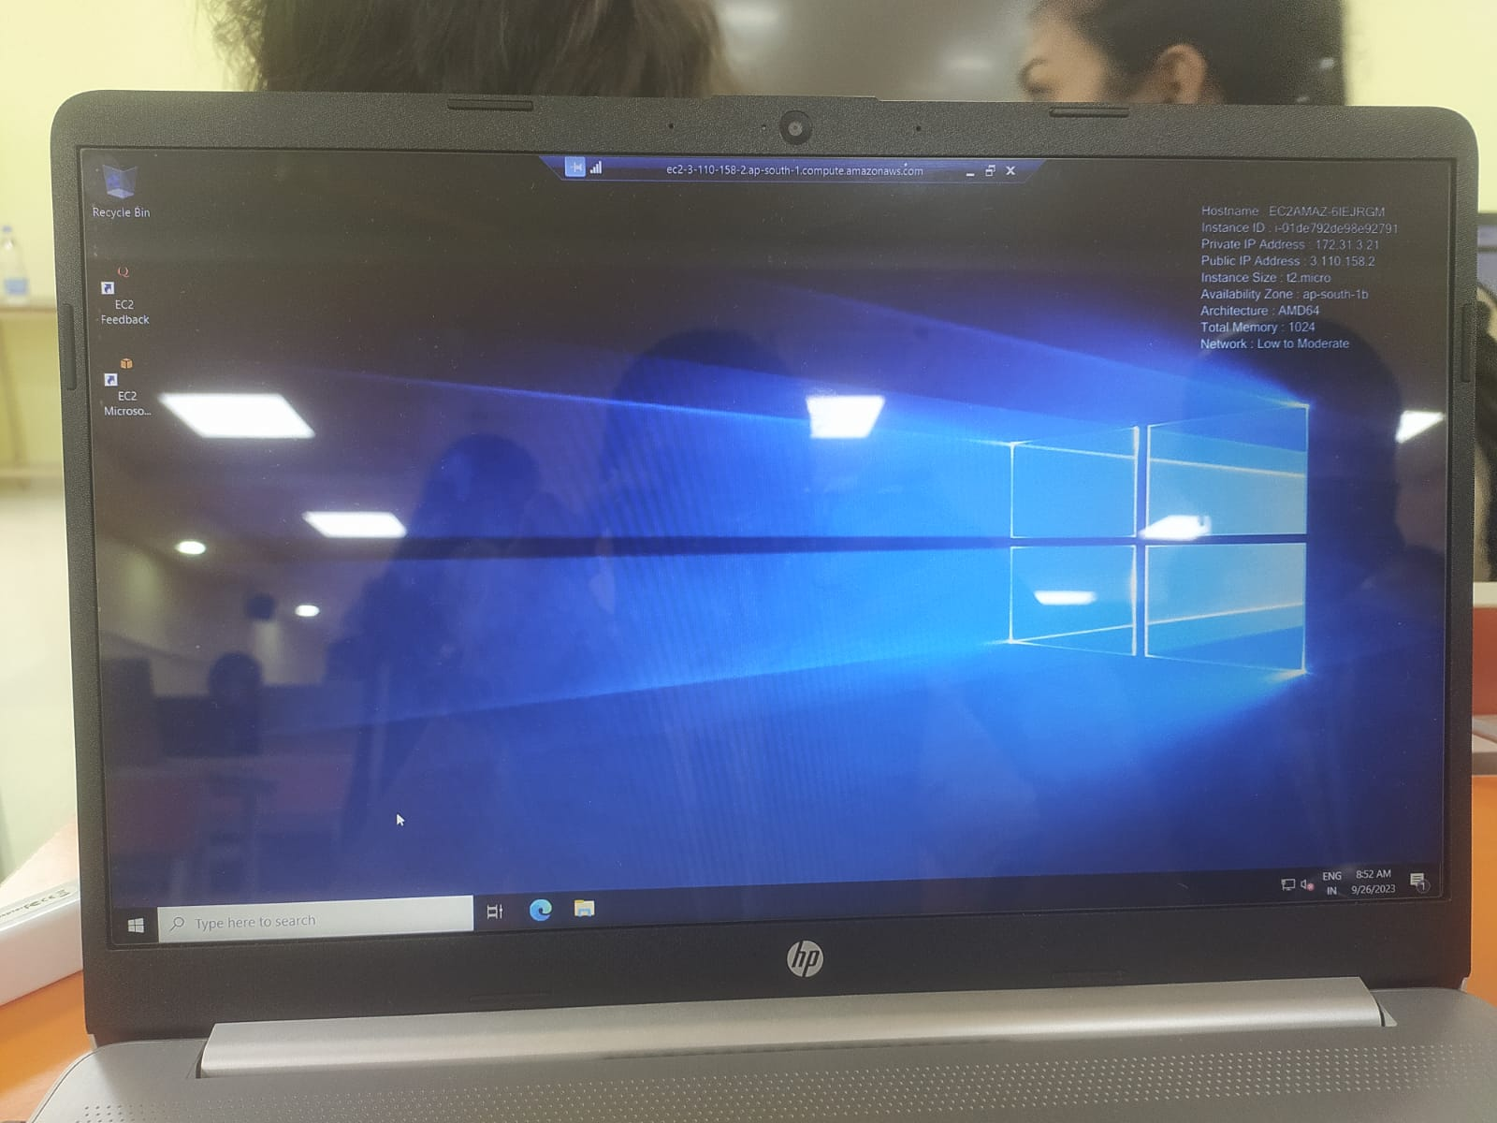

Step.1:first we have to launch in the ec2 tab

Step.2:now we have to select ami of free-tier and the instance type

Step.3:next create the key pair whatever u like to keep

Step.4:connect to the remote desktop connection

Step.5:enter the username and password

Step.6:windows instance will be launched